Interview Question Bank

Table of Contents

C Language 3
Real Time OS 6
Operating System 8
VoIP & SIP 10
Networking 16
Device Drivers 18
Linux Programming 19
Compiler & Debugging 20
Atlanta 2000 Processor 21
Data Structures 22
Puzzles 23
VxWorks Interview Question 24
Ericsson ,Bangalore 28
nVIDIA ,Pune 29
Miscellaneous 30

C Language

- What is Stack overflow, what is cause other than Recursion? [One Access,Cisco]

- What’s is the Problem with library function Strcpy?[Sonus]

- Where is Union used? [Sonus]

- Which system call GDB uses?
Ptrace()

- Which System call Malloc uses?
Sbrk()

- How to allocate create structure element with dynamic buffer size ?
Last element should be char a[0]

- How to implement Timer and callback?

- What is stack trace and how to debug using Stack Trace?

- What is dangling Pointer?

- What is memory Leak? How to Detect and Avoid?
Const pointer while allocating.

- What is callback Function? How to implement?

- What are storages classed in C.
http://www.tenouk.com/ModuleZ.html

- Where is function pointer used and how it is defined? [Sonus,Radisys]
main()
{
int(*fptr)(); //Function Pointer Declaration
fptr=foo; //Assigning
fptr(); //Calling
}

foo()
{
printf("Hello There");
}

- How to detect stack is growing upwards or downwards.[Juniper]

- Write a function to print maximum number of contiguous 1's in bitwise format of string
int function(char *arr) : input arr[2]: arr[0]='a', arr[1]='e'

- In a binary tree, print the level at which maximum no. of nodes are present [Cisco]

- Purpose of C prototype?
http://stackoverflow.com/questions/3763960/purpose-of-c-c-prototypes

- What are the memory areas in C.?
http://nandu310.wordpress.com/2009/11/09/memory-areas-in-c-language/

- What is the output of following Program?
int *p=0;
p++;
printf("%d",p);

- Program to find substring in a string? [Juniper]
- How to swap the two nibbles in a byte ?
Try this

#include < stdio.h >

unsigned char swap_nibbles(unsigned char c)
{
unsigned char temp1, temp2;
temp1 = c & 0x0F;
temp2 = c & 0xF0;
temp1=temp1 << 4;
temp2=temp2 >> 4;

return(temp2|temp1); //adding the bits
}

- Test Little endian system
Short is 16 bit
here 1is at lower address and 0 at higher
so in big endian it will be 256 and little it will be 1

int main()
{

unsigned char endian[2] = {1,0};
short x;

x = *(short *) endian;
printf("%d",x);
}

- How to fast multiply a number by 7?

(num << 3) - num)

Real Time OS

- How interrupt handling is Done in RTOS?
- What is pre-emption Patch?
- What is low latency Patch?
- What is RTOS?
- Why Linux in not RTOS?
- What changes need to done to Linux to make it RTOS? [ST Micro 2007]
- What is Priority Inversion? What is priority Inheritance and Priority Ceiling?
- What's difference between general purpose OS and RTOS

Operating System

- What is difference between Mutex and Binary Semaphore
Mutex
Mutex is locking mechanism.
It has ownership info,i.e which has acquired it only can unlock it.
Mutexes may not be used in hardware or software interrupt

Semaphore
Semaphore is signaling mechanism.
Doesn’t have ownership info,so they can be unlocked in different context

VoIP & SIP

- Difference between Via and Route?
- What is Dialog and transaction? How many transactions are there in single call?
Dialog/Call Leg is same.

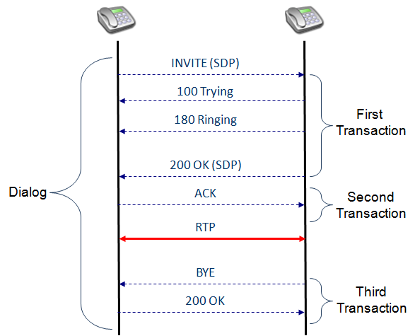

In the example 1,
(a) to (c) are one transaction.
(d) is second transaction and
(e)& (f) constitute third transaction.

Together, these three transaction constitute one dialog

- What is Loop and what parameters you will see to detect A loop or how to detect?
- How to detect the response of immediate request?
This is called transaction and it’s identified by branch Id in via header.

Via: SIP/2.0/UDP 10.255.1.30:5060;branch=z9hG4bK3763983732-38
You can see branch- id in the via header that is the transaction number...
Since sip is a transaction protocol so it required
transaction number to send a request and get response for this
transaction.

- What is different between Session Vs Dialog?
After dialog established, if the call is successful and media starts
Flowing (RTP), then it is said to session established.
For Register request, dialog establishes but there is no media, so no
Session.

- What is call forking?
- What is early dialogue and confirmed Dialogue?

Early Dialog:- A dialog established by a non final response.
Confirmed Dialog:- After getting 2xx response.

- Difference between Record-route & route?
- Explain important headers in RTP?
- Why RTP uses UDP?
- What is Refer? And where it is used?
- What are the Mandatory general headers you will see in SIP Requests and Responses?
- What is SIP Protocol Structure /Stack?
- Draw Call Flow of Call waiting and 3way conference?[Samsung]
- What is present in Auth Headers of INVITE in case of IMS ?[Samsung]
- What are P-headers present in SIP message when using IMS ?[Aricent,Samsung]
P-Associated-URI
– URIs associated to an address of records
P-Called-Party-ID
– Identity the session was addressed to
P-Visited-Network-ID
– Check roaming agreements and authorize registrations
P-Access-Network-Info
– Information about the access network used by the terminal
P-Charging-Function
– Charging entities for a session
P-Charging-Vector
– Charging identifiers and networks performing charging
P-User-Database
– Optimization for queries to the HSS

- what are headers/differences in INVITE and CANCEL message ?[Samsung]
- What is difference between Via ,Route,Record-route,Path field?[Samsung,Radisys]
- What is difference between Session and Dialog?[Aricent]
- Who adds record route in Case of IMS?[Samsung]
- How DTMF is send in VOIP?
3 common ways of sending DTMF on SIP calls
>>SIP INFO packets
-------
INFO sip:7007471000@example.com SIP/2.0
Via: SIP/2.0/UDP alice.uk.example.com:5060
From: <sip:7007471234@alice.uk.example.com>;tag=d3f423d
To: <sip:7007471000@example.com>;tag=8942
Call-ID: 312352@myphone
CSeq: 5 INFO
Content-Length: 24
Content-Type: application/dtmf-relay

Signal=5
Duration=160
-----

>>As specially marked events in the RTP stream - see: RFC 2833
>>inband as normal audio tones in the RTP stream with no special coding or markers

- What is Loose Routing and Strict Routing? [Radisys]
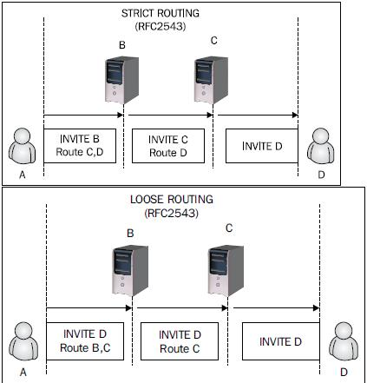

- What is P-asserted Identity Header?[Aricent]
- Difference between Proxy and B2BUA ?[Sonus,Tata Elixis,Aricent]
- Draw Call flow of Attended Transfer ?[Aricent]
- What is OMA Specs?[Aricent]
- Which Layer of TCP/IP SIP is involved?[Radisys]
- In OSI model, how SIP packet is formed and traversed?[Radisys]
- Which field is added in SIP packet at each process in IMS Server?[Radisys,Samsung]
- Draw the call flow from host A to host B in IMS Server?[Radisys]
- What are components of IMS-Core and function of Each and where located (Home or Visited Network)?[Aricent,Samsung]

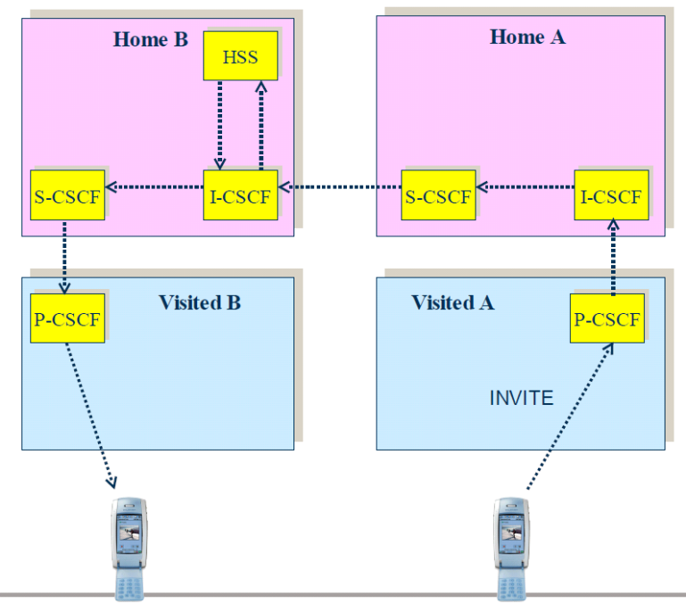

  - The P-CSCF resides in the visited network.
It acts as the UE's gateway into the UE's home network. The P-CSCF is responsible for:
Identifying the home IMS network.
Routing traffic to and from the home IMS network.
Establishing the IPSec security association

- The I-CSCF resides in the home network. It acts as the front-end of the Home IMS network.
The I-CSCF is responsible for:
Interfacing with the P-CSCF in the visited network.
Selecting the S-CSCF by querying the HSS.

- The S-CSCF resides in the home network.
The S-CSCF is responsible for:
Handling the registration request from the I-CSCF.
Pulling the authentication vectors from the HSS
Passing the authentication vectors to the P-CSCF via the I-CSCF.
Authenticate the user in the second registration attempt.

- What are different SIP Request?[Samsung,Aricent]
- Draw call flow of Cancelled INVITE?
- When we should TCP or UDP for Sending SIP Message?[Samsung]
TCP should be used when message size is too large to be fit in one frame ( 1500 Bytes)
This is normally needed in case of IMS as SIP messages has too many headers.
Also when there is no PRACK available.

- What is via, Branch, Tag?
- What is Early dialog?
- Give me an example when servers send 5XX response?
- What are Branch ID and Tag ID in SIP?
- What is path Header?
The Path header field is a SIP extension header field with syntax
very similar to the Record-Route header field. It is used in
conjunction with SIP REGISTER requests and with 200 class messages in
response to REGISTER (REGISTER responses).
- how to add multiple contact in register and remove one contact from register.
- stateless vs stateful proxy ?what is used in gateway?

Networking

- Diff between UDP and TCP

- How does Ping Works?

- How does Tracert Works?

- Loopback Address in IPv4 and IPv6
The most commonly used IP address on the loopback device is 127.0.0.1 for IPv4, although any address in the range 127.0.0.0 to 127.255.255.255 is mapped to it.
IPv6 designates only a single address for this function, 0:0:0:0:0:0:0:1 (also written as ::1)

- How is IPv6 denoted?

- TCP - for every data packet there is ack? Don't you think it's bandwidth wastage?

- What is 3-Way handshake in TCP ?[Akamai]

- What is socket?[Akamai]

- What is function of each layer in TCP/IP ?[Akamai]

- What are types of IPv6 Address?

- Explain working of HUB and Switch?[Radisys]

- Why Does IPV6 doesn’t Contains Checksum filed like IPV4?
IPv6 Header does not include checksums on the assumptions that if checksums are required then
then it will be done by AH header which provides strong authentication of entire packet.

Device Drivers
- What should we do in open, close device drive functions?
- Which Driver should be implemented in kernel space & which one in user space?
- Block and character and network driver?
- Kernel space and user space driver and examples?
- What care should be taken while writing ISR ?
- What is use of Modules other than Drivers?
- What are SoftIRQs,Tasklets & Workqueue?
- Which of above is used in ISR and process context?
- What the various entry points you worked in your device Driver?
- What is the system call to map Device Register Space ?
(ioremap etc )
- API to readwrite in Hardware in readl and writel
- network interface entry points -set_multicast_list,set_mac_address,hard_start_xmit,do_ioctl
- locking primitives used to syncronise data between isr and process context spinlock_irq or spinlock_irq_save ( Mutex is wrong)
- Some concept of PCI based driver
- debugging-Breakpoints, crash , core,,kdumps
- What is GPF_KERNEL and GFP_ATOMIC in kmalloc?
- What is difference between Vmalloc and kmalloc?
- Debugging using GDB?
(how to add breakpoints,How to see threads,how move PC up/down)
- Explain kernel Build process (kernel compilation procecss)?
- Explain initrd and its use?
- how will test drivers with various version of kernel?
- How to pass paramter to Module while insmod?
insmod,modprobe or /etc/modprobe.conf
- How to register IRQ ?
- Explain system calls related PCI device and how pci device initiliazes?
- What locks are used in ISR and in driver?
- Ways to debug kernel/module code?
(BUG(),early printk,printk,syslog,oops,panuc,kallsyms,gdb)
- What is diff between modprobe and insmod?
- What kind of information .ko files has?

Linux Programming

- Gives usage scenario of IPC mechanisms
What is the application which uses shared memory, i mean when fifo, message queues are available to exchange data between multiple tasks, in what scenerio shared memory comes into picture

- Where the shared memory resides and some basic understanding.
http://www.techrepublic.com/article/shared-memory-where-it-belongs-in-the-computer-space/5033533
http://www.technovelty.org/linux/shared-memory.html
http://www.kernel.org/doc/gorman/html/understand/understand015.html

Compiler & Debugging

- What does strip command does?
- How to use GDB ?
http://www.ibm.com/developerworks/library/l-gdb/

- What are components of Compiler?
http://www.nku.edu/~foxr/CSC407/NOTES/compilertechnology.txt

Atlanta 2000 Processor

Data Structures

Puzzles
- There are 25 racing cars. At a time only 5 cars can be in a race. There is no timer or something similar. Find out how many times you need to run race, so that you can find SECOND fastest car.

VxWorks Interview Question
Q: What is a RealTime System ?
A: A Real-time system is defined as a system where the response time for an event is predictable and deterministic with minimal latency.
Q: How is RTOS different from a general operating system?
A:
TaskScheduling:
RTOS generally have priority-based preemptive scheduling, which allows high-priority threads to meet their deadlines consistently. Whereas In a GPOS, the scheduler typically uses a "fairness" policy to dispatch threads and processes onto the CPU. Such a policy enables the high overall throughput required by desktop and server applications, but offers no assurances that high-priority, time-critical threads will execute in preference to lower-priority threads.
Preemetive Kernel:
In RTOS, kernel operations are preemptible. And so the RTOS kernel must be simple and elegant as possible.
Mechanisms to Avoid Priority Inversion:
This occurs when a lower-priority thread can inadvertently prevent a higher-priority thread from accessing the CPU. VxWorks specifically has protection for this.
Q: What is a task in VxWorks?
A: A task is an independent program with its own thread of execution and execution context. VxWorks uses a single common address space for all tasks thus avoiding virtual-to-physical memory mapping. Every task contains a structure called the task control block that is responsible for managing the task's context.
Q: How do task's manage the context of execution ?
A: Every task contains a structure called the task control block that is responsible for managing the task's context. A task's context includes
· program counter or thread of execution
· CPU registers
· Stack of dynamic variables and function calls
· Signal handlers
· IO assignments
· Kernel control structures etc.,
Q: What are the Different states of tasks?
A task has 4 states. Read, Pend, Delay, Suspended
Q: Explain the task State transition ?
A: A task can be created with taskInit() and then activated with taskActivate() routine or both these actions can be performed in a single step using taskSpawn(). Once a task is created it is set to the suspend state and suspended until it is activated, after which it is added to the ready queue to be picked up by the scheduler and run. A task may be suspended by either the debugging your task, or the occurrence an exception. The difference between the pend and suspend states is that a task pends when it is waiting for a resource. A task that is put to sleep is added to delay queue.
Q: What is the default scheduling algorithm in vxWorks?
A: By default, vxworks scheduler runs preemtive priority based algorithms. You can change it to rounds robin/timeslicing algorithm.
Q: What are the different types of semaphores in vxworks? Which is the fastest?
A: VxWorks supports three types of semaphores. Binary, mutual exclusion, and counting semaphores. Binary is the fastest semaphore.
Q: When will you use binary semaphore ?
A: Binary semaphores are used for basic task synchronization and communication.
Q: When will you use mutual exclusion semaphore?
A: Mutual exclusion semaphores are sophisticated binary semaphores that are used to address the issues relating to task priority inversion and semaphore deletion in a multitasking environment.
Q: When will you use Counting semaphore?
A: Counting semaphores maintain a count of the number of times a resource is given. This is useful when an action is required for each event occurrence. For example if you have ten buffers, and multiple tasks can grab and release the buffers, then you want to limit the access to this buffer pool using a counting semaphore.
Q: How do you do inter task communication in vxworks?
A: Using message Queues.A variable number of messages, each of variable length, can be sent to any task.
Q: What the special requirements for message Q's and Semaphore handling inside ISR's ?
A: ISR can only send Messages and can only release a semaphore
Q: Can Message be scheduled on priority ?
A: Yes. Multiple tasks can wait on a single message queue and can be ordered by their priority. Messages can be marked urgent for faster delivery.
Q: How is ISR handled in vxworks ?
A: VxWorks supplies interrupt routines which connect to C functions and pass arguments to the functions to be executed at interrupt level. To return from an interrupt, the connected function simply returns. A routine connected to an interrupt in this way is referred to as an interrupt service routine (ISR) or interrupt handler. When an interrupt occurs, the registers are saved, a stack for the arguments to be passed is set up, then the C function is called. On return from the ISR, stack and registers are restored.
Q: How do you connect the C Function to any interrupt?
A: Using intConnect(INUM_TO_IVEC(intNum), intHandler, argToHandler).
The first argument to this routine is the byte offset of the interrupt vector to connect to. The second argument is the interrupt handler and the last is any argument to this handler.
Q: What are the important things to be taken care within ISR?
A:
Avoid blocking calls
No wait for semaphore
No receive messages
No malloc() or free() (since they internally wait fro semaphore)
Q: How can ISR's communicate with user tasks?
A: using:
shared memory and ring buffers
release of semaphores
signaling tasks
writing to pipes
sending messages using message queue
Q:What interfaces are generally exposed from the drivers to application?
A: creat(), remove(), open(), close(), read(), write(), ioctl() are the seven standard driver interfaces that are exposed to application.
Q: Which routine you call to install the driver ?
A: iosDrvInstall()
Q:What is context switching?
A: When the scheduler preempts a task it has to store the current state of the task in task's context storage area and will retrieve it later when the task is resumed. The current runnable tasks context is retrieved. This process of switching the contexts is called task switching or context switching.
Q: Is it possible for an ISR to preempt another ISR?
A: It is possible for an ISR to preempt another ISR, however this is board dependent and may not be allowed. The handling of the hardware interrupt, that in turn invokes the ISR registered for the interrupt, is board specific and is performed by the board support package software (BSP). VxWorks provides an API that allows the developer to register an ISR with the BSP's board specific handler. This abstraction layer allows for board specific code to be segregated from the remainder of the application thus allowing for easier porting to new board types.
Q: How can you stop your code from scheduler preemption?
A: You can tell the system not to preempt your code by using taskLock() and release it later once you finished your critical section code using taskUnlock().
Note this is not a suggested mechanism, as the code cannot be interrupted. Also this might lead to unacceptable real time behavior, because a higher priority task can preempt a lower priority task that locked itself.
Q: What is re-entrency and how you achieve it?
A: If a piece of code can be used by more then one task without the fear of data corruption, then it is said to be Reentrant. A reentrant function can be interrupted at any time and resumed latter without loss or corruption of data.
To achieve reentrancy, use either local variables (i.e variables on stack rather then on heap, and CPU registers etc.,) or treat the code as critical section and protect the data.
Q:How you guarantee cache coherency?
A: This is typically done in two ways.
1) Mark a portion of memory within your RAM as non-cachable. Allocate cache safe buffers from this memory.
2) Alternatively, use cacheFlush() and cacheInvalidate() routines provided by VxWorks. If Device is reading data from RAM, first flush the cache and then read data. If Device is writing to RAM, write to RAM and then invalidate the cache immediately. This way CPU's cache will be in sync with RAM.

Ericsson ,Bangalore

4 Rounds 45 Min Each

R1.C
R2.SIP/VOIP
R3.DATA STRUCTURE
R4.GENERIC (All above again)

C question
1.How to implement memcpy and memmove and whats the difference
2.How to implement sizeof macro
3.Pointers Questions
4.Explain any code that liked very much in ur project
5.what are commands to debug using gdb.
6.how to debug multithreaded program
7.use of void pointer
8.typedef for function pointer

Data Structure
1.implement grep or pattern matching program,what kind of data structure is used.
2.Reverse link list
3.advatangage /disadvanate of Array,singly link list and doubly link list

SIP/VOIP
1.Expain LTE infrastructure-EnodeB,SGN,PDNGW,PCRF ,IMS Element
2.How call ID is made
3.how sip stack detects that transaction from client is invalid.

nVIDIA ,Pune

Round 1
Manager general capablty
tools used
how big codebase i have worked on
working in our organization
tools and branches in cvs
which data structure of phone book

Round 2
How to pass array to Function & print each element
How to pass double array to Function and print each element
Calulate size of loop and start of loop in linked list containing loop
reverse a link linked list
implement strcpy function take care of overflow
count number of ones in number
check whether number is power of 2
how to intialize all elemet of single and double array

Nvidia, Pune F2F
How does free and malloc works?
Make your free and malloc?
How does spinlock works in uniprocessor system?
How to implement sleep in driver?
How to implement timer?
How to give multiple access to driver?
Find whether system is Big endian or small endian using union?
What work in gfx validation?
There is big file , Write a program to fastly display file on screen?
typedef int myint vs typedef myint int
difference between typedef and define?
implement timeout and timer function?

Miscellanous
Reverse link list?
Rever string?
how to do overlap copy - memmove?
strcpy vs memcpy?

Miscellaneous

- jobinterviewquestions.co.in
http://vijayinterviewquestions.blogspot.com/

- Embedded Articles
http://www.ganssle.com/articles/

- Pointers and Memory
http://cslibrary.stanford.edu/102/

